**Group Project Assignment: Battle along a water body (here e.g. Rhine)**

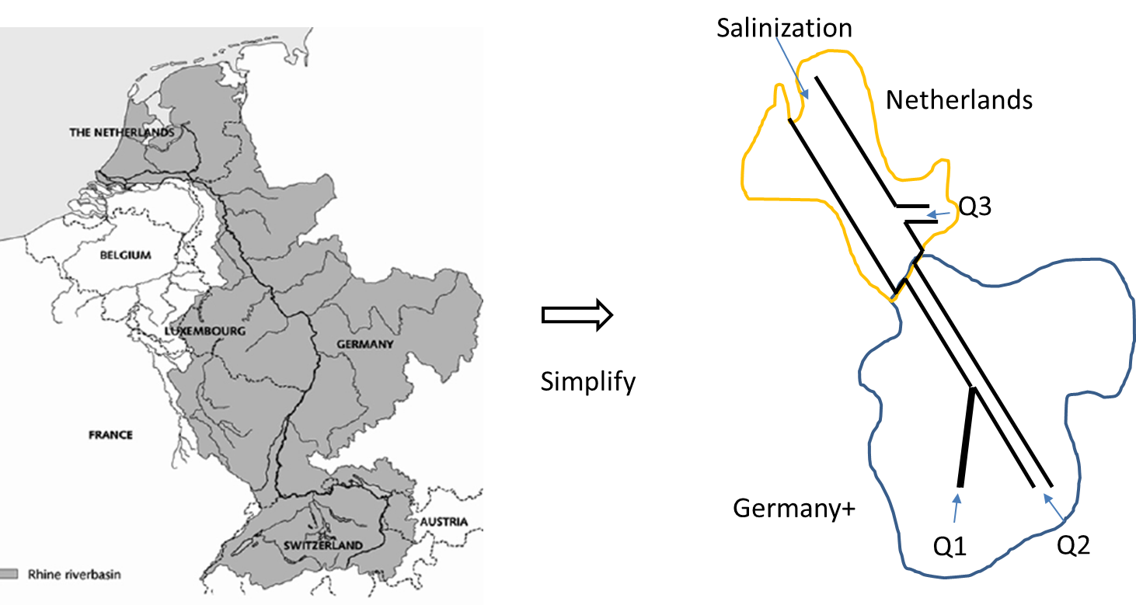

Form groups of 3 to build a real world, low dimensional, coupled human-environmental quality model, by addressing the following objectives:

* Build a simplified water quality model for a water body of your choice using simplified geometry at steady state
* Gather socio-economic and hydro-climatic data to estimate pollution loading into the water body over time (assuming no treatment)
  + e.g. Fertilizer based such as nitrates or phosphates
* Simulate pollution in the water body over generations
* Build coupled economic growth and environmental quality model for the water body for sustainable development. E.g. for the river the figure
  + Rhine tax? Controlled consumption? Role of technology? Should Gemany+ pay Netherlands?

The building blocks of the coupled model will be covered over the course of the lectures and the modelling steps will be discussed. Please attend lectures for that.

The presentations for the group project will be held before the final exam (date and location to be announced), while the project report will be due within the week following the written exam, if not before. The assessment guideline is on the following page.

**Project assessment guideline**

The group project assignment will be evaluated along 3 lines below. The first two will carry a weight of 30% each, while the third will carry a weight of 40% of the overall grade.

1. Engineering skills
   1. Technical quality of results (e.g. calculations)
   2. Computer skills (e.g.) programming
   3. Interpretation of results
   4. Usability of results for societal impact/sustainable development
2. Academic approach
   1. Argumentation
   2. Extension of knowledge or methods discussed in class
   3. Ambition level: amount of work
   4. Creativity: new ideas, innovative use of data and knowledge
3. Reporting and presentation
   1. Structure and consistency: is it complete and holistically answering the assignment
   2. Language proficiency
   3. Use of literature and references
   4. Use of figures, tables and equations
   5. Story line of the presentation and report.

Each group presents for max 12 mins and max 7 mins are for discussion (total of ~ 20 mins per group) .